1. Use the internet to find a website that shows an example or application of correlation or regression in an area of interest in your personal or professional life. X
2. **Discuss how correlation or regression was used**, summarize your findings, and share them. X
3. Be sure to include the independent and dependent variable - discuss the impact/relevance of the independent variable. X

The Harvard T.H. Chan School of Public Health conducted a study that found air pollution (over years) may make the effects of COVID-19 worse (The President and Fellows of Harvard College, 2020). Ecological regression analysis was used to study the association between PM2.5 exposure, the independent variable, and COVID-19 mortality, the dependent variable. The U.S. Environmental Protection Agency (EPA) has linked PM2.5 (particles with diameter, ≤ 2.5 μm) exposure to negative health effects particularly on respiratory and cardiovascular systems. The study concluded that there is an association between PM2.5 exposure and COVID-19 mortality with an 11% increase in mortality for every 1 microgram/cubic meter in polluted air (Wu et al., 2020). To mitigate against COVID-19 mortality in areas with high concentrations of air pollution, it is critical that social distancing is practiced.

Figure 1

*National Maps of Historical PM2.5 Concentrations and COVID-19 Deaths*

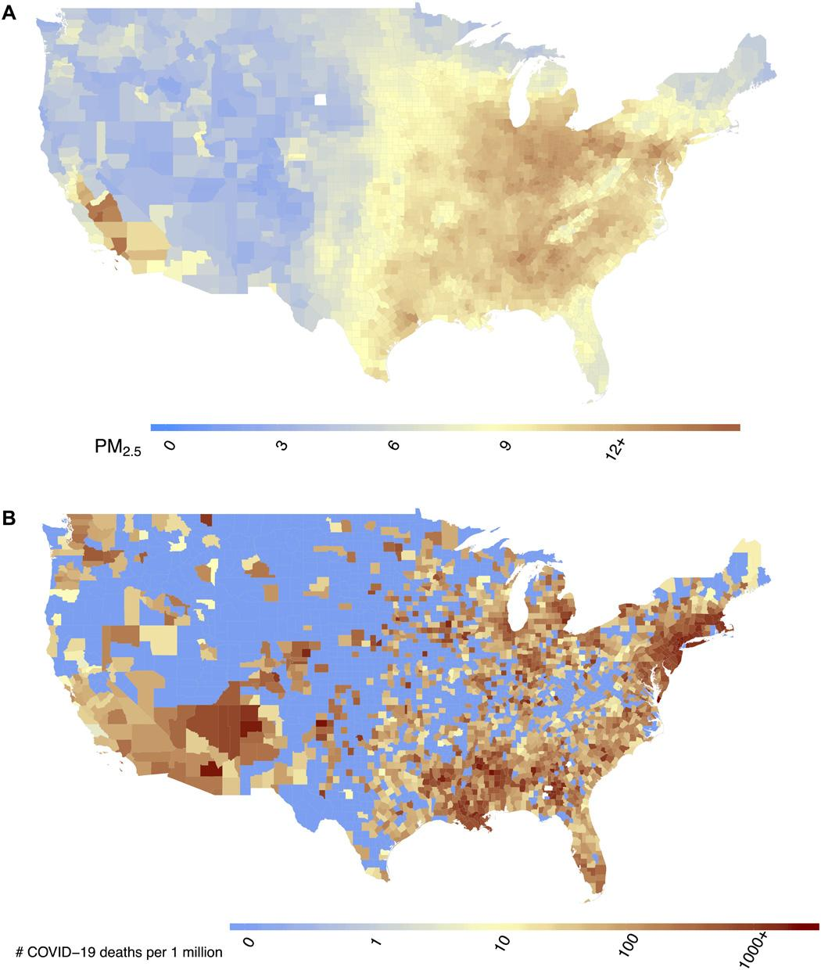

*Note*. Maps show (A) county-level 17-year long-term average of PM2.5 concentrations (2000–2016) in the United States in μg/m3 and (B) county-level number of COVID-19 deaths per 1 million population in the United States up to and including 18 June 2020. Reprinted from *Science Advances, 6*(45), by Wu, X., Nethery, R. C., Sabath, M. B., Braun, D., & Dominici, F. 2020. American Association for the Advancement of Science. Copyright 2020 by the American Association for the Advancement of Science.

References

Harvard T.H. Chan School of Public Health. (2020). *Coronavirus and Air Pollution.* The President and Fellows of Harvard College. Retrieved November 26, 2020, from <https://www.hsph.harvard.edu/c-change/subtopics/coronavirus-and-pollution>

Wu, X., Nethery, R. C., Sabath, M. B., Braun, D., & Dominici, F. (2020). Air pollution and COVID-19 mortality in the United States: Strengths and limitations of an ecological regression analysis. *Science Advances, 6*(45). <https://doi.org/10.1126/sciadv.abd4049>

--------------------------

Hi Justin,

Following up on Dr. Humphreys post, I’d be curious to know what labor force participation looks like when examined by the education area of study. For instance, Applied Mathematics majors have one of the highest average annual total incomes near $130,313 (Hoff, 2020) whereas Sociology majors have a median base salary of $42,000 (Berry, 2018). I’d also be interested to see how the pandemic has affected labor force participation across education level.

Lauren

References

Hoff, M. (2020, May 19). *The 20 highest-paying college majors in the US*. Business Insider. <https://www.businessinsider.com/college-majors-with-high-average-salaries-post-graduation-2020-5#20-physics-majors-had-an-average-annual-total-income-of-121500-and-288100-have-at-least-a-bachelors-degree-in-this-field-1>

Berry, A. (2018, July 8). *50 Highest Paying College Majors*. Glassdoor.

<https://www.glassdoor.com/blog/50-highest-paying-college-majors/>

We know that gender and race play a role on these factors as well

Hi Matthew,

I’d be interested to know what the levels of personal finance education look like across gender and race given numerous wealth disparities. Single women often pay more for mortgage loans and are denied more often than single men or couples. Further, single women borrowers are more likely to be women of color (Ellevest Team, 2020). When it comes to higher education, although women comprise 57% of higher education students, they carry almost two-thirds of nationwide student debt. Black women graduate with most of the student debt at $30,400 as compared to white men at $19,500 (AAUW, 2018). Ultimately, women can expect to retire on average with two-thirds the money men do (Olson, 2016). I think understanding how and when and what personal finance education is communicated to women and people of color is essential to closing the gap on these disparities.

Lauren

References

AAUW. (2018, May 21). *Analysis: Women Hold Two-Thirds of Country’s $1.4-Trillion Student Debt*. American Association of University Women. <https://www.aauw.org/resources/news/media/press-releases/analysis-women-hold-two-thirds-of-countrys-1-4-trillion-student-debt>

Ellevest Team. (2020, June 26). *60+ Stats About Women and Money*. Ellevest.

<https://www.ellevest.com/magazine/disrupt-money/stats-about-women-money>

Olson, E. (2016, June 3). For Many Women, Adequate Pensions Are Still a Far Reach. *The New York Times*. <https://www.nytimes.com/2016/06/04/your-money/for-many-women-adequate-pensions-are-still-a-far-reach.html>